# THANK YOU!

Thank you so much for backing the Open Hand Project, since your pledge we’ve come a very long way and none of this would have happened without your help. I hope you enjoy your reward and I would love any feedback on how you’ve used your Dextrus hand or any feedback you have on the design. You can contact me at joelgibbard@openbionics.com.

## Dextrus v2.0

The Dextrus v2.0 has a number of changes from the Dextrus v1 hands which appeared in the OHP indiegogo videos. It now uses flexible joints and linear actuators which have several key changes to the way it functions. The Dextrus v2.0 has…

* Flexible joints, which make the fingers mechanically compliant when being forced closed.
* A much smaller circuit board, which reduces the volume of the hand significantly.
* Linear actuators, which are more powerful and much lighter than the previous DC motors.
* 5 Actuators instead of 6; a cost, size and weight saving measure that has a minor effect on functionality (the thumb no longer has independent opposition).
* 3.5mm headphone jack to connect the EMG daughter electronics.
* A rubberized body, which makes the hand much more robust to dropping and grasping things.
* A unibody design, which makes the hand much smaller, lighter and easier to assemble, but makes replacing individual fingers impossible if broken (although the entire hand only costs around £20 to print, so can be replaced with relative ease).

When using the Dextrus v2.0 you should **always leave the hand in the open position when not in use**, with all fingers and the thumb completely extended. This will help to prevent joint fatigue. If you find you’ve accidentally left fingers in the closed position for a long period of time simply open them completely and leave them open for several hours and they should return to their original position. This device is still a prototype so be careful with it and please get in touch if anything breaks. We’re continuing our development and working very hard on improving all aspects of the design.

|  |  |
| --- | --- |
| **Dextrus v2.0 Device Specification** |  |
|  |  |
| Operating Voltage Range | 9V-14V |
| Recommended Voltage | 12V |
| Max Current Draw | 1.2A @ 12V |
| Idle Current Draw | 40mA @ 12V |
| Power Connector | Standard DC Jack |
| Control Interface | USB serial |
| Peripheral Connectors | 2 Analog channels on 3-pin 3.5mm Headphone Jack |
| Mechanical Connectors | M3 Bolts |
| License | [Creative Commons Attribution-ShareAlike 4.0 International License](http://creativecommons.org/licenses/by-sa/4.0/). |

## Open Hand Project

Since you backed the Open Hand Project back in 2013 things have moved on enormously. The original mission was to make advanced robotic prosthetics affordable and accessible and this has been pushed further and further towards a reality over the last two years. The Open Hand Project evolved into a company, Open Bionics, so named just in-case we wanted to look at other limbs in the future and we’ve since fitted several amputees with prostheses in testing. Key milestones have included creating the world’s first custom fitted, 3D printed robotic prosthetic hand and then innovating the design hugely before creating a new prototype, which was half the size and weight and considerably cheaper than its predecessor.

The original Dextrus design has been downloaded over 2000 times all over the world and several people have made their own hands from the designs. Most recently, a man in America fitted a Dextrus hand to his friend Taylor, a wounded war hero (pictured below). Just like the original designs, all of our prosthetic designs will continue to be released for free under a [Creative Commons Attribution-ShareAlike 4.0 International License](http://creativecommons.org/licenses/by-sa/4.0/).

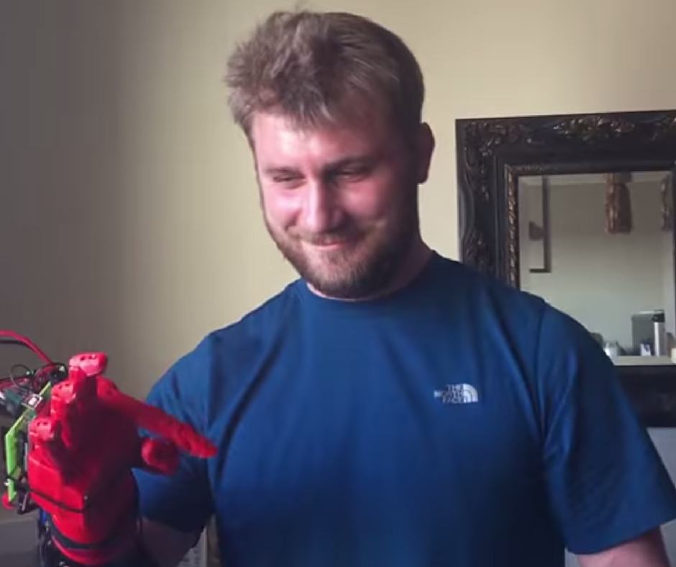

Since the indiegogo campaign we’ve spent a lot of time with amputees, finding out exactly what they need from a prosthetic and learning about how it can benefit them. We’ve learnt that some people don’t need the world’s most advanced prosthesis but do want something that looks really interesting and appealing. We’ve taken all of this feedback on board and are applying it to our latest prototypes. Grace, shown in the image below, is wearing our Swarovski crystal encrusted robotic hand!

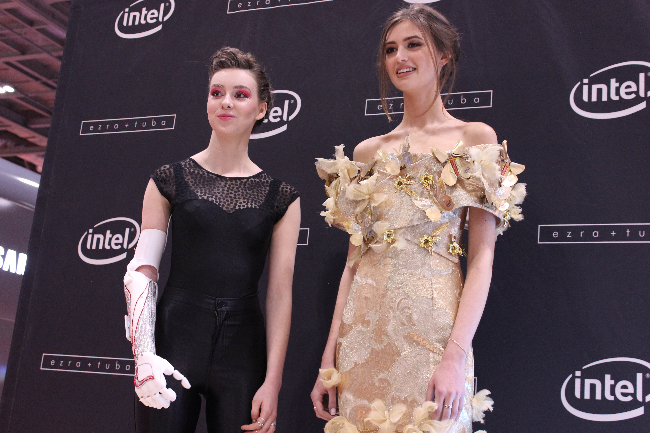

Our latest goal is to field test our hands with amputees to find out exactly how they will be used and what impact they have on day-to-day life. We recently had the pleasure of meeting Nigel Ackland, who was one of the first people in the UK to be fitted with the BeBionic robotic hand. Nigel considers the moment he first put on the BeBionic to be a turning point in his life and meeting him was a great point of inspiration for us.

We hope you’re as proud as we are of all of the work we’ve achieved so far, we only hope we can keep moving this industry forward and pushing the boundaries of what’s possible with prosthetics.

## Resources

[www.openhandproject.org](http://www.openhandproject.org)

[www.openbionics.com](http://www.openbionics.com)

<http://creativecommons.org/licenses/by-sa/4.0/>

[hello@openbionics.com](mailto:hello@openbionics.com)

[joelgibbard@openbionics.com](mailto:joelgibbard@openbionics.com)